**Project**

**LSTAT2130 : Introduction to Bayesian Statistics**

Philippe Lambert

Hortense Doms

Year 2021-2022

Jessica De Rongé

Didier Termont

Antoine Visschers

Table of Content

Question 1: 1

Question 2 2

Question 3 4

*Question 3.A* 4

*Question 3.B* 5

*Question 3.C* 5

Question 4 6

Question 5 9

*Question 5.A* 9

*Question 5.B* 9

*Question 5.C* 10

# Question 1:

The objective of the survey was to study the profile of cannabis’ users. Because the use of cannabis is not necessarily legal everywhere and the overall negative reputation of users in today’s society, researchers discover that asking the question “Have you recently used cannabis?” made people uneasy to answer. Thus, the interviewers created a process which aims to make people fill at ease with answering the question. The process consists of making the interviewees roll two dices and in function of the result they would either answer truthfully or answer “yes” regardless of their habits concerning cannabis’ use. So, if the respondent got a double six, he would have to answer “yes” and if not, he would answer truthfully.

Thus, the proportion of people who answered “yes” does not correspond to the proportion of people who do smoke cannabis in the population. To calculate g the probability of a random person would answer yes in the survey, the law of total probability is used (knowing that the probability of cannabis’ users in the population is π).

Y corresponds to the answer to the question “Have you smoked cannabis?” (yes=1) and D is the event that a participant “rolled a double 6”. From the law of total probability, we can write:

P(Y) = P(Y|D) x P(D) + P(Y|Dc) x P(Dc)

Where:

* P(D) = 1/36
* P(Dc) = 1-P(D) = 35/36
* P(Y=1|D) = 1 Indeed, if we know that the respondent got a double six, we can affirm that he will answer yes to the question and thus, we can deduce that P(Y=0|D) = 0.
* Y|Dc ~ Ber(π)

The probability g, the probability that an interviewee answered “yes”, is determined as follows:

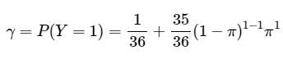

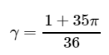

It is thus possible to conclude that ϒ is following a Bernoulli distribution with parameter g:

# Question 2

Y is the random variable corresponding to the number of “yes” answered in the survey. We can find its distribution given what we have found about ϒ in the previous section.

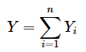

Where

Thus, given g, Y follows a Binomial distribution with parameters n (number of participants in the survey) and g.

Y ∼ Bin (n, g)

Having discovered the distribution of Y, the next step is to define the posterior distribution of p. The Baye’s theorem is used to find this distribution:



∝Likelihood x Prior

Thus, to compute the posterior distribution, the prior distribution of p is needed, as well as the likelihood which is based on the observed data of the survey. Starting with the prior, as no prior information is given about the proportion of cannabis users in the population, a non-informative prior distribution has been chosen. Therefore, p ∼Uni(0,1) which is a special case of a beta distribution with parameter a=1 and b=1. Thus:

P(p) ∝ 1

The likelihood P(Y|p), as we know that Y, given g, follows a binomial distribution and that g is a function of p, it is possible to deduce that the likelihood is as follows:

P(Y|p) ∝gy (1-g)n-y

Where n is the number of people in the sample and y is the number of success (here, understood as answering yes to the question “have you recently smoked cannabis?”).

Since the prior distribution and the likelihood have been both computed, it is possible to find the posterior distribution:

This expression is simplified by following those different steps which consist in bringing out a constant.

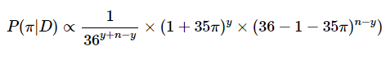

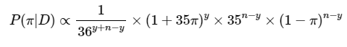

Thus, the following expression is the simplified version of the posterior distribution up to a multiplicative constant.



# Question 3

## *Question 3.A*

The metropolis algorithm has been computed on the R software based on the logarithm of the posterior distribution found in the previous question. The objective of the algorithm is to produce a random sample of p. The starting value chosen for p is 0.5. Different values of standard deviation have been tested. The choice made on this value is based on the acceptance rate. The literature believes that a suitable standard deviation should be around 0.4 in a univariate case. However, usually a value of acceptance rate included in the range 0.3-0.5 is accepted. Thus, the chosen value is 0.02 which gives us the acceptance rate of 0.5. However, in this project, choosing the value for the standard deviation leads sometimes to produce an error in R which would indicate that NaN were produced. Using 0.02 was a value that did not create such a problem, and which led to an acceptable value of acceptance rate. Having calculated the effective size, the information given by the random sample gives as much as the information of 272 independent values of p.

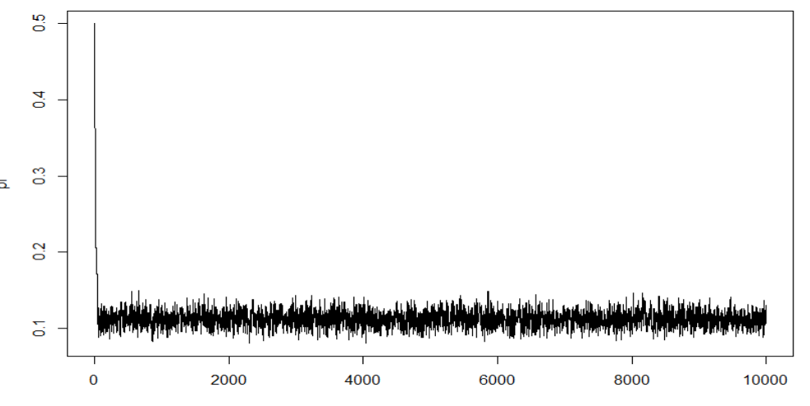

Concerning the convergence of the generated sample, the only way to ensure convergence is asymptotically through the metropolis algorithm. As you can see on the graph, it seems that it converges quite quickly, only after 200 iterations it can be seen that there is convergence. However, there are different tools that are helpful to study convergence. However, none of these tools are able to prove convergence. They may be used to see if there is no convergence happening. The first one is the Gelman-Rubin diagnostic (also known as the R statistic) which consists of comparing the between and within variance of different chains. Having a statistic close to 1 is a necessary condition to have convergence. Different chains with different starting values have been created to be able to conduct the Gelman-Rubin diagnostic and the statistic has been computed and gives us a R statistic equal to 1.

The second tool used to analyze convergence is the Geweke diagnostic which consists of testing if two means are equal. In the metropolis algorithm, the sample is divided in two samples to compute the p value and see if it is different. This division and test are done multiple times in the sample. Having all the different statistics being between -1.96 and 1.96 is again a necessary condition to have convergence. As seen in the graph, all the statistic observed are in between the two thresholds.

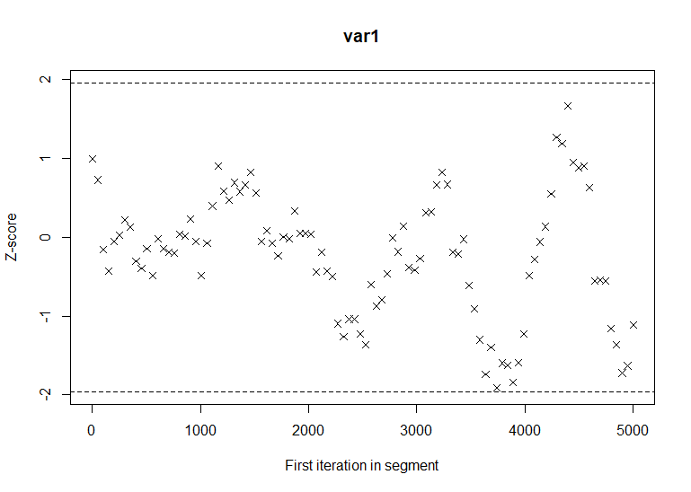

## *Question 3.B*

To find the plausible value of p, a 95% credible interval is measured on the sample for pi. The burn-in part of the sample must be removed. The plausible value of p found through the previous result are 0.093 and 0.13. Thus, this interval does not include the value 0, so it can be said that p is different from 0.

lower upper

0.09276152 0.1325527

## *Question 3.C*

The posterior probability that among 20-59 year olds, there is at least 10% of cannabis’ users is equal to 91.88%.

# Question 4

The metropolis algorithm has been calculated for both women and men separately. The value of the standard deviation has again been chosen based on the acceptance rate. The same starting value as for the question 3 has been used. The answer to this question is seperated in three different sections. The first one is consecrated to the study of p for the male population. The second one is dedicated to the study of the female population and the proportion p of cannabis’ users in this population. The third and last part focuses the studying the difference of proportion of cannabis’ users between men’s population and women’s population (d).

1. **Men**

The chosen value is 0.033 which gives us the acceptance rate of 0.49. Having calculated the effective size, the information given by the random sample gives as much as the information of 1353 independent values of p. The traceplot shows that the value found by the algorithm converge quite quickly. The Geweke diagnostic has also been tested and as you can see in the plot, no value of z computed through the test is higher or lower than 1.96 and -1.96 respectively. The Geweke plot tells us that it does not dectect any problem of convergence in the sample produced but it is not sufficient to say that convergence does occur. The traceplot shows us asymptotic convergence which is the only guarantee that convergence happens in this case.

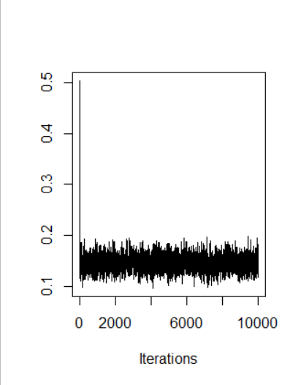 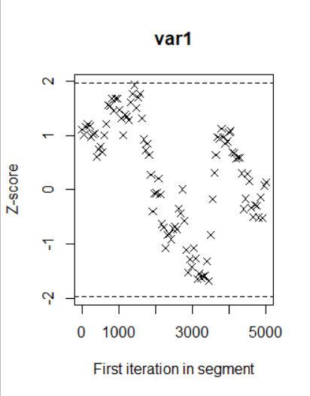

A 95% credible interval has been computed to find the plausible value of p for the men and gives us an interval going from 0.11 to 0.17.

lower upper

0.1155972 0.174957

The posterior probability that among 20-59 years old men, there is at least 10% of cannabis’ users is equal to 99.94%

1. **Women**

The value of the standard deviation chosen is 0.024 which gives us the acceptance rate of 0.53. The acceptance rate is a little higher than what is considered an acceptable rate. However, when the value was increase, there were some problems of convergence found in the Geweke plot. The traceplot shows that the value found by the sample converges quite quickly. This asymptotic convergence showed in the plot is what is supposed to ensure that convergence does happen. The Geweke diagnostic is used to see if there is no convergence, however it cannot prove that convergence does occur. The Geweke plot shows no value of z computed through the test is higher or lower than 1.96 and -1.96 respectively. Having calculated the effective size, the information given by the random sample gives as much as the information of 712 independent values of p.

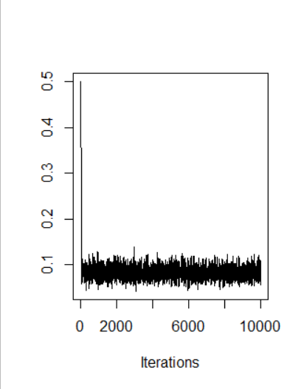 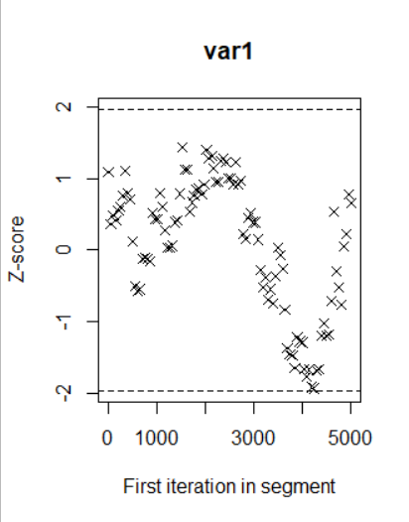

The plausible value has been computed through a 95% credible interval which start at 0.057 and finish at 0.108.

lower upper

0.0572117 0.1080703

The posterior probability that among 20-59 year old women, there is at least 10% of cannabis’ users is equal to 9.36%

1. **Delta (d)**

The graph below plots both the sample of the value of p for men (in blue) and the value of p for women (in red). The plot shows that both random samples are converging quite quickly (in the first 200 iterations, vertical black line). The graph also seems to inform us that there is a possibility that the men (in black in the graph) have higher value of p than women (in red). Indeed, the two chains are not covering the exact same area of possible value, the red chains covering lower values than the black chains.

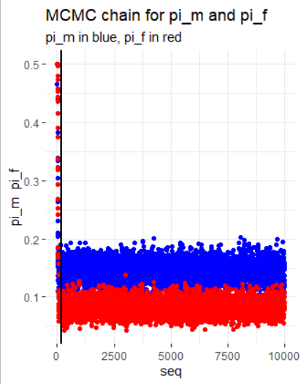

To test this difference of value, delta d (corresponding to p male minus p female) has been calculated. The plausible values of delta have been computed. The 95% credible interval lower born is equal to 0.025 and the higher born is equal to 0.1. As the fact that the interval does not include 0 and is positive, it would mean that men have a higher proportion of cannabis’ smokers than woman. Moreover, if we compare the plausible values found for men and women, the interval for men contained higher values than the one for the women.

lower upper

0.02495858 0.1019836

To further confirm this result, the probability that delta is bigger than 0 has been calculated and is equal to 99.9%. Thus, it is possible to conclude that proportionally less women than men have recently smoked cannabis.

# Question 5

## *Question 5.A*

Two different logistics regressions have been computed using JAGS through R. The first one evaluates the influence of the age of men on the probability of smocking cannabis, the two estimated coefficient are a0 and a1 and the model is the following

Where hx is equal to a0 + a1 (x - 40) and where x is the variable age and px is the probability of being a cannabis’ user.

The second model analyzes the same relationships between using cannabis and the age. However, this time only the women’s population is taken into account, the two estimated coefficient are thus b0 and b1 and the model is the same as previously. The only difference is that hx is now equal to b0 + b1 (x - 40), where x is the variable age and px is the probability of being a cannabis’ user.

## *Question 5.B*

The value of a1, b1 as well as d (which correspond to a1-b1) have been computed:

Mean SD

alpha1 -0.05565 0.01317

beta1 -0.02118 0.01541

delta -0.03447 0.02031

The plausible values for the parameters have also been calculated through a 95% credible interval for both chains that were computed are:

lower upper

alpha1 -0.08159186 -0.02985568

beta1 -0.05077894 0.00919725

delta -0.07387524 0.00531428

lower upper

alpha1 -0.08229530 -0.030398752

beta1 -0.05090265 0.009365515

delta -0.07260832 0.008103085

The difference between the two chains is different starting values. However, the plausible values for both chains are very similar which gives more confidence in the study of the different parameters.

Concerning a1, both intervals do not include zero and are similar. Thus, it can be said that the logit probability that a man older than 40 years old smokes will decrease. However, when he is younger than 40 years old, the logit probability will rise as he grows older until he is 40.

Concerning b1, as both intervals include the value 0. It is not possible to reject the null hypothesis, that b1 is equal to 0. Thus, we cannot conclude that for the women population, the age plays a role to explain if a person is a cannabis’ users.

Regarding d, the plausible value of both intervals includes 0. Thus, the null hypothesis cannot be rejected. Thus, in conclusion the data does not permit to say that d is different from 0. Following this conclusion, it is not possible to say that b1 and a1 are different.

## *Question 5.C*

The value of h found for a 25 year old man is

Mean SD

etha_m_25 -1.04408 0.18976

Having discovered h, the probability than a 25 year old man being a recent cannabis’ user can be computed using the inverse of the logit function which gives us the result that the proportion of users is 26.23%. The distribution of the posterior probability that a 25 year old man is a recent cannabis users can be visualised as follows:

